Reiki Class

Usui Reiki Levels 1 and 2
Level 1 - Friday, April 25th 6 - 9:30pm
Level 2 - Saturday, April 26th 9 - 4pm

Washington Healing Arts Center
426 E. 5th Street
Washington, MO
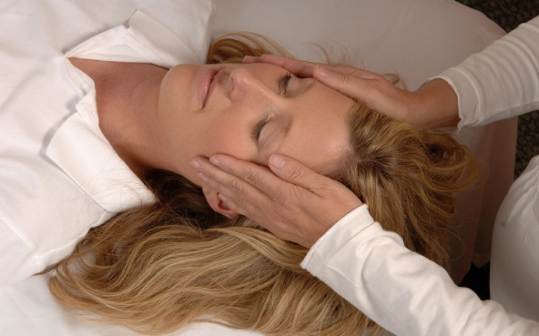
Cost - $225 - Level 1 & 2 Discover the gentle healing power of Reiki
- $125 for just one level -$50 Refresher Class for previous students

Reiki is a gentle method of hands-on healing that taps into the universal life energy flowing through all the systems of the body to promote balance, health and well-being. Studies of Reiki show significant reduction of pain, increased feeling of relaxation and a sense of well-being. Reiki is used in many hospitals all over the world and is a wonderful complement to medical treatment, psychological counseling and bodywork.

This class includes two attunements, all the Reiki hand positions, Reiki 2 symbols, distance healing techniques, and the International Center for Reiki Training manual.

For more information please call Julie Dotson 314-805-9544 or Dale Lintzenich 636-667-0300

To Register please complete the form below.
~ ~ ~ ~ ~ ~ ~ ~ ~ ~ ~ ~ ~ ~ ~ ~ ~ ~ ~ ~ ~ ~ ~ ~ ~ ~ ~ ~ ~ ~ ~ ~ ~ ~ ~ ~ ~ ~ ~ ~ ~ ~ ~ ~ ~ ~ ~ ~ ~ ~ ~ ~ ~ ~ ~

Registration

Usui Reiki Level 1 & 2 Apr 25& 26 ______ $225 Deposit $50
Usui Reiki Level 1 Apr 25 ______ $125
Usui Reiki Level 2 Apr 26 ______ $125

Washington Healing Arts Center
426 E. 5th Street
Washington, MO

Name ___________________________________ Phone ________________________

Address ___________________________________________________
__________________________________

Email ___________________________________________________

Deposit - $50 due by Apr 21st .
Mail check payable to Julie Dotson, 103 Meadow Lane, Labadie, MO 63055

